PAM PRIZE – EXCELLENCE IN THE MEDITERRANEAN
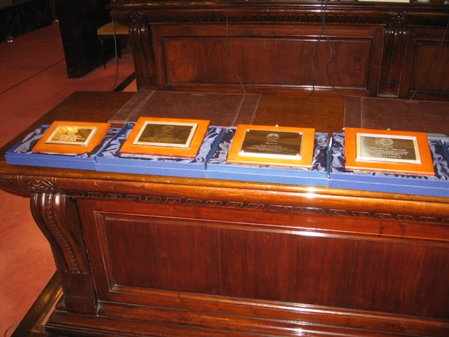

Personalities and Organisations from the political, institutional, diplomatic and economic fields, as well as NGOs were today awarded the PAM PRIZE 2011. The presentation ceremony was held as part of the VI PAM Plenary Session which was hosted by the Italian parliament in Palermo, Italy on 29 October 2011.
Introducing the presentation ceremony PAM Secretary General, Dr. Sergio Piazzi recalled that the Parliamentary Assembly of the Mediterranean, represents today a solid foundation for regional Parliamentary diplomacy and therefore must continue to thrive if there is still a real concern about the active participation of all stakeholders in a democratic societies. “We have had the opportunity here in Palermo to discuss the events that have been triggered in many southern Mediterranean countries by the citizens themselves. PAM will continue to be at the forefront to assist, where requested, in the transformation processes of these fellow member states and their people”, Dr. Piazzi said.
The PAM PRIZE is aimed at helping national delegations identify those who have distinguished themselves in initiatives and activities, be they cultural, economic, social or academic, dedicated to the achievement of those principles and goals set by the Assembly and which are common to all people of goodwill.

Awards were also presented, as a sign of gratitude, to those personalities and organizations that have collaborated with and supported PAM in its activities during the current year.

PAM PRIZE 2011  Excellence in the Mediterranean  (List of Organisations and Personalities in alphabetical order)  NAME | MOTIVATION
Ms. Lidia Brito  Director of the Division of Science Policy  and Sustainable Development in the Natural  Sciences Sector of UNESCO | In recognition of her role in the partnership with PAM in the field of Science and Technology as instruments of peace and progress in the Mediterranean region.
Arch. Michele Capasso -  President of Fondazione Mediterraneo – Maison de la paix | For the longstanding commitment towards intercultural dialogue in the Mediterranean region and the continued support to PAM endeavours.
H.E. Mr Jan Kubis  Executive Secretary of UNECE  - The United Nations Economic Commission for Europe | For the efforts in supporting PAM in promoting economic development and social integration in the Mediterranean region on the occasion of the Joint Conference held in Geneva on 4-5 May 2001 at a critical time for our region.
Dr Miltiadis Makriyannis –  Head of the Department for Regional Cooperation and Partnerships of the Hellenic Parliament in charge of the Mediterranean, Black Sea and Southeast Europe Affairs. | For his long service and in recognition of his high contribution to the enhancement of parliamentary diplomacy in the Mediterranean region
Mr. Mauro Pandimiglio –  President Handy Cup Onlus - Italy | For their commitment in promoting awareness on disability and social disadvantage issues in the Mediterranean region.
Mr.Lino Spiteri -  President of Inspire - Foundation for Inclusion | For their commitment in promoting awareness on disability and social disadvantage issues in the Mediterranean region.
Prof. Umberto Veronesi –  President of Fondazione Veronesi – | In recognition of the contribution to the Science for Peace 2011 Programme and his personal and his Foundation’s endeavours in medical research and assistance in the Mediterranean region.
Hon. Alain Delcamp Secretary General of the French Senate- | For hosting the 2nd Meeting of the Secretaries General of Parliaments of States surrounding the Mediterranean, held in Paris, France on 28 February, 2011.
H.E. Mr. Abdel Mawgoud El Habashi – Egyptian Ambassador to Malta | For the crucial support extended to PAM to facilitate the Mission of the UNSG Special Envoy to Libya.
Hon. Michael Frendo – Speaker of the House of Representatives of Malta | For his commitment in supporting PAM activities and for your initiatives for enhanced cooperation between the Parliament of Malta and the institutional functioning of the PAM Secretariat.
The Prefect Franco Gabrielli – Head of the Civil Protection Department – Italy – | For hosting the Conference ‘Oil spill in the Gulf of Mexico: is the Mediterranean Ready?’, held in Rome, Italy, on 18 May. 2011.
H.E. Dr. Saadun Ismail Suayeh – Libyan Ambassador to Malta – | For the outstanding support to PAM to maintain the relations with Libya throughout the political transition process.
H.E. Amb. Giulio Terzi di Sant’Agata Italian Ambassador to Washington – | In appreciation for your personal support to the PAM High Level Delegation during the visit to the US Senate, Congress and Administration on 21-22 September

